Adding and Subtracting Fractions
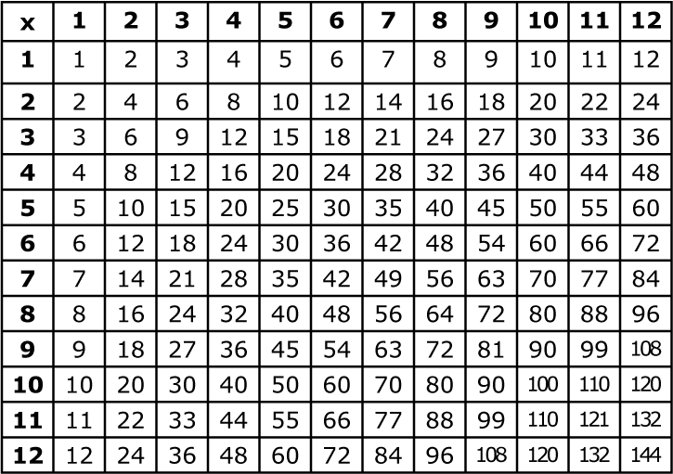
1. Find a common denominator.
- List the first few multiples of each denominator. Find the lowest number in common.
2. Change your fractions to have the common denominator (by multiplying).
3. Add or subtract your new fractions.
- Add or subtract the NUMERATORS
- Leave the DENOMINATOR the SAME.

copy problem:
_____ _____ = _____

1. Write the first few multiples of each denominator. Circle the lowest common number.
x | 1 | 2 | 3 | 4 | 5 | 6 | 7

2. Rename your fractions: Multiply the numerator and denominator by the factor that is above your circled number.

_____ x _____ =

_____ x _____ =

3. Rewrite your problem with your new fractions. Then add or subtract.
_____ _____ = _____
Are your denominators the same?

_____ _____ = _____
x | 1 | 2 | 3 | 4 | 5 | 6 | 7

_____ x _____ = _____

_____ x _____ = _____

_____ _____ = ____

_____ _____ = _____

x | 1 | 2 | 3 | 4 | 5 | 6 | 7

_____ x _____ = _____

_____ x _____ = _____

_____ _____ = ____
_____ _____ = _____

x | 1 | 2 | 3 | 4 | 5 | 6 | 7

_____ x _____ = _____

_____ x _____ = _____

_____ _____ = ____

_____ _____ = _____

x | 1 | 2 | 3 | 4 | 5 | 6 | 7

_____ x _____ = _____

_____ x _____ = _____

_____ _____ = ____

